Media Release
For immediate release
29 June 2026

Calls grow for a clear pathway for nature-based early childhood education
A campaign has been launched calling on the Government to create a clear licensing pathway for safe, high-quality nature-based early childhood education in Aotearoa.

The Make Room for Nature Kindy campaign follows the ceasing of operations of Play and Learn’s Nature Kindergarten, a long-running nature-based early childhood programme, after the ECE licence it operated under was cancelled.

The closure has affected 58 tamariki and 15 staff.

Little Kiwis Nature Play founder Celia Hogan says the situation has highlighted a much wider issue.

“New Zealand does not currently have a clear licensing pathway for early childhood education where nature is the main place of learning,” says Hogan.

“Many ECE centres can run nature days, bush kindy sessions and outdoor programmes as excursions from licensed centres. But that is different from being able to establish a primarily nature-based early childhood service in its own right.”

The campaign is asking the Government to create a clear pathway so safe, high-quality nature-based ECE can operate in Aotearoa with strong safeguards in place.
“This is not about asking every centre to become a nature kindy,” says Hogan.

“It is about making provision for families and providers who want this kind of learning, so there is a clear, safe and properly recognised pathway.”

Nature-based ECE can include qualified teachers, supervision structures, risk management, health and safety systems, Te Whāriki, parent communication, emergency planning and Ministry oversight.

“Nature kindy is not unregulated childcare in a park,” says Hogan.
“It is education, outdoors. Tamariki are learning through movement, relationships, play, risk, observation, care for the environment and connection to te taiao.”

The issue is not new. In 2019, a submission and petition were brought to Parliament asking for a clear pathway for nature-based early childhood education otherwise known as bush kindy or nature kindy. There was cross-party support at the time, but the work lost momentum after MPs changed, key people left Parliament and COVID hit.

Since then, nature-based learning has continued to grow across Aotearoa.

“This is an election year, and MPs and candidates are out in communities listening to issues that matter,” says Hogan.

“Now is the time to put this back on the table.”

The campaign is encouraging people to share their stories, contact MPs, complete a provider survey, post on social media using #MakeRoomForNatureKindy, and ask local media to cover the issue.

A Save Nature Kindergarten community event will be held on Friday, 24 July, 4pm, at Long Bay.

Media contact:
Celia Hogan
Little Kiwis Nature Play
celia@littlekiwisnatureplay.com
022 158 2113
www.littlekiwisnatureplay.com
#MakeRoomForNatureKindy
#SaveNatureKindy

Key Information Sheet - Make Room for Nature Kindy
Safe, high-quality nature-based ECE needs a clear pathway in Aotearoa.

What has happened?
Play and Learn’s Nature Kindergarten, a long-running nature-based early childhood programme, was cancelled after the ECE licence it operated under was cancelled.
This has affected 58 tamariki and 15 staff.

What is the wider issue?
New Zealand does not currently have a clear licensing pathway for early childhood education where nature is the main place of learning.
ECE centres can run nature days, bush kindy sessions and outdoor programmes as excursions from licensed centres.
But that is different from being able to establish a primarily nature-based early childhood service in its own right.

Legislative context
Current ECE licensing settings are built around fixed premises, indoor space and centre-based provision.
Under the Education (Early Childhood Services) Regulations 2008, centre-based ECE services must meet premises and facilities requirements, including Schedule 4 activity space requirements.
For an early childhood education and care centre, Schedule 4 lists:
- indoor activity space: 2.5 square metres per child
- outdoor activity space: 5 square metres per child, or a minimum number of square metres per child determined under regulation 54(3)
These rules make sense for traditional centre-based provision, but they do not provide a dedicated pathway for an early childhood service where the outdoor environment is the normal place of learning.
At the moment, centres can run nature days, bush kindy sessions and outdoor programmes as excursions from a licensed centre.
But providers cannot simply establish a primarily nature-based early childhood service under a clear licensing pathway.
That is the gap.

What is the campaign asking for?
The campaign is asking the Government to:
Create a clear licensing pathway for safe, high-quality nature-based early childhood education in Aotearoa.
This is not about asking every centre to become a nature kindy.
It is about making provision, so families and providers who want safe, high-quality nature-based ECE have a clear pathway.

Why does this matter?
Nature-based learning supports movement, play, confidence, resilience, curiosity, relationships, wellbeing and connection to place.
For many tamariki, this is where they thrive.
Aotearoa values the outdoors. Our education system should be able to make room for safe, high-quality learning in nature too.

Evidence snapshot
- Children have a recognised right to rest, leisure, play and recreational activity under Article 31 of the UN Convention on the Rights of the Child.
- Sport NZ guidelines say young people aged 5 to 18 should have at least 60 minutes of moderate to vigorous physical activity each day.
- Sport NZ’s 2024/25 Active NZ survey notes that tamariki are more likely to be active when they feel connected to their environment and whānau.
- Research shows positive links between children’s contact with nature and health, especially physical activity and mental health.
- A systematic review of risky outdoor play found overall positive effects on children’s health indicators and behaviours, especially physical activity, with benefits also linked to social health and behaviour.
- Te Whāriki supports learning through relationships, exploration, wellbeing, belonging, contribution and communication. High-quality nature-based ECE can sit strongly within this curriculum.

What would a clear pathway include?
A clear pathway should keep strong safeguards in place, including:
- qualified teachers and skilled adults
- supervision structures
- risk management
- health and safety
- Te Whāriki
- parent communication
- emergency planning
- suitable outdoor learning environments
- Ministry oversight and accountability

Is this issue new?
No.
In 2019, a submission and petition were brought to Parliament asking for a clear pathway for bush kindy, forest school and nature-based early childhood education.
There was cross-party support at the time, but MPs changed, key people left Parliament, COVID hit, and the work lost momentum.
Since then, nature-based learning has continued to grow across Aotearoa.

What can people do?
People can help by:
- sharing their story
- emailing their local MP or election candidates
- completing the provider survey if they run a nature-based or outdoor learning programme
- sharing the campaign with their networks
- posting a photo, short reel or story using #MakeRoomForNatureKindy
- inviting MPs or candidates to visit nature-based programmes
- contacting local media and asking them to cover the issue
- supporting the Save Nature Kindergarten community event on Friday 24 July, 4pm, at Long Bay

Sources to link
Education (Early Childhood Services) Regulations 2008, Regulation 45 and Schedule 4
Ministry of Education: Premises and facilities for centre-based ECE services
Ministry of Education: Indoor activity areas
Sport NZ: Guidelines for children and young people aged 5 to 18 years
Sport NZ: Active NZ Survey 2024/25
UN Convention on the Rights of the Child, Article 31
Nature and Children’s Health: A Systematic Review
What is the Relationship between Risky Outdoor Play and Health in Children? A Systematic Review
Te Whāriki early childhood curriculum

Campaign contact
Celia Hogan
Little Kiwis Nature Play
celia@littlekiwisnatureplay.com
022 158 2113
www.littlekiwisnatureplay.com
#MakeRoomForNatureKindy

Quote Sheet

Celia Hogan, Little Kiwis Nature Play
“New Zealand does not currently have a clear licensing pathway for early childhood education where nature is the main place of learning.”
“Nature kindy is not unregulated childcare in a park. It is education, outdoors.”
“This is not about asking every centre to become a nature kindy. It is about making provision for families and providers who want this kind of learning.”
“Many centres can run nature days and bush kindy sessions as excursions from licensed centres, but that is different from being able to establish a primarily nature-based early childhood service in its own right.”
“We are asking for good regulation that protects children, supports quality and makes room for outdoor learning.”
“Aotearoa values the outdoors. Our education system should be able to make room for safe, high-quality learning in nature too.”
“For many tamariki, nature-based learning is where they thrive. We see confidence, curiosity, resilience, relationships and connection to place grow when children have regular time outdoors.”
“This issue was raised with Parliament in 2019 and had cross-party support at the time. The work stalled, but the issue has not gone away.”
“This is an election year. MPs and candidates are listening, visiting communities and looking at issues that matter. Now is the time to put this back on the table.”
“The issue is not a lack of demand, quality or safety practice. The issue is that the current system does not provide a clear pathway for this model.”
“The issue is not whether nature-based ECE can be safe. The issue is that the current licensing system does not make room for it as a model in its own right.”

Parent or whānau voice
“Nature-based learning has given our child confidence, freedom, resilience and a deep connection to the world around them.” Bush Kindy Parent
“We need more opportunities for children to learn outside, not fewer.” Bush Kindy Parent
“This kind of learning matters because children need real experiences, movement, play, relationships and time in nature.” Bush Kindy Parent

Photos

Photographer: Celia Hogan
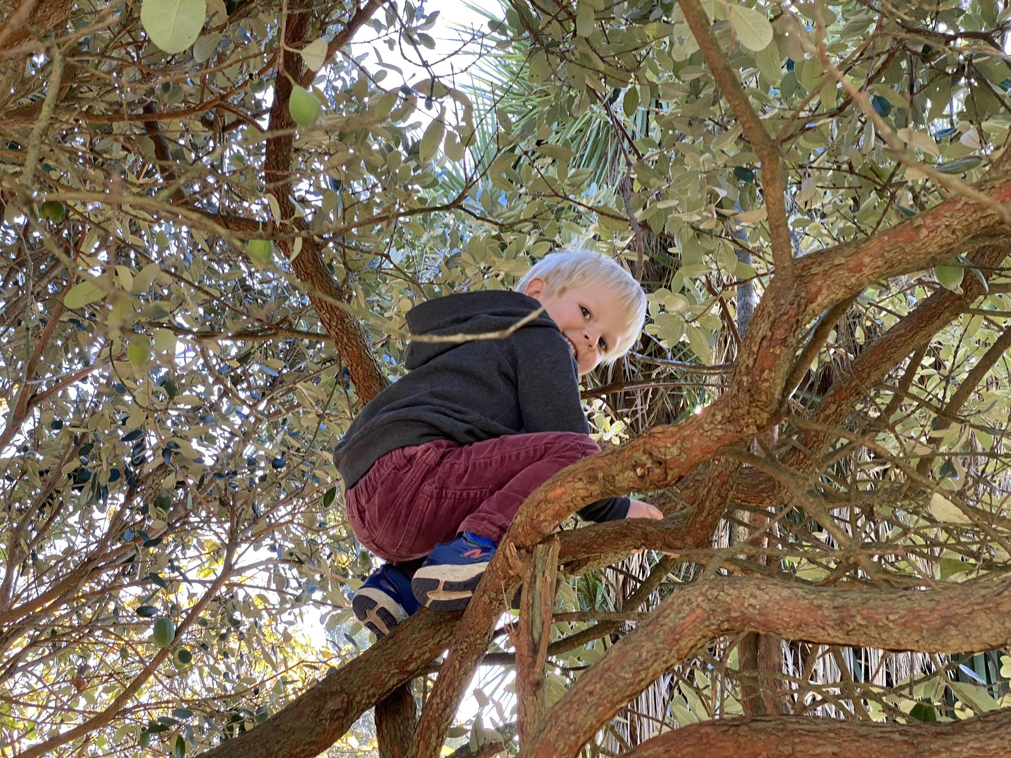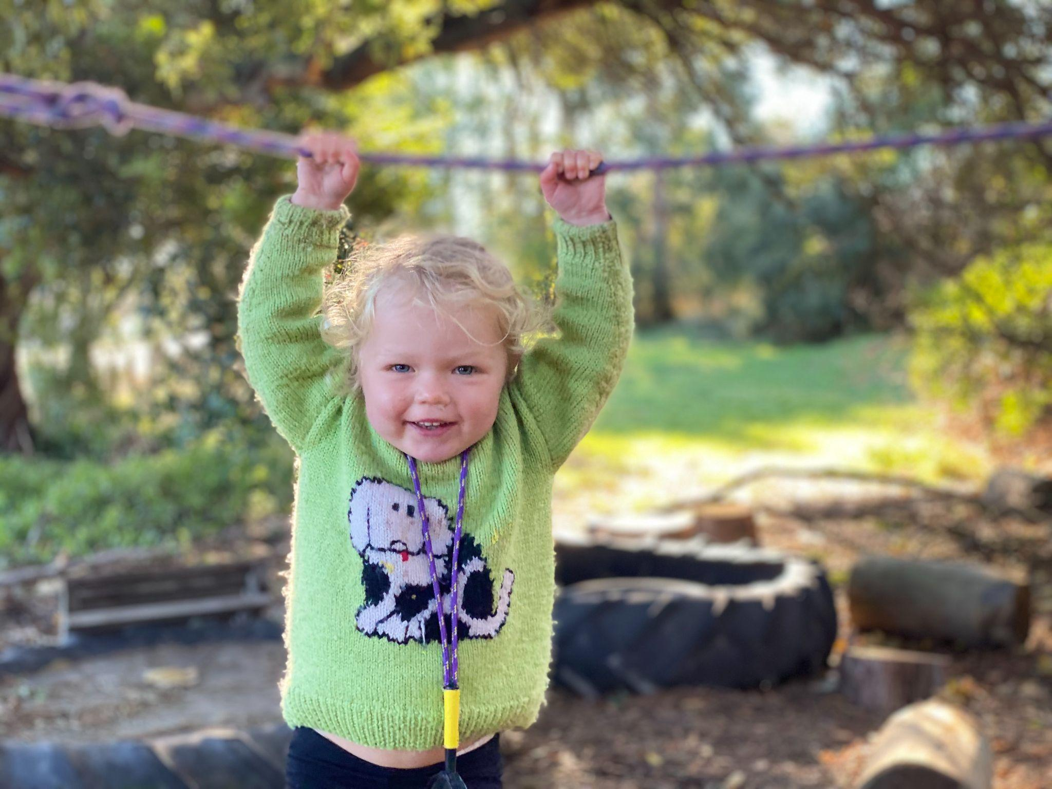
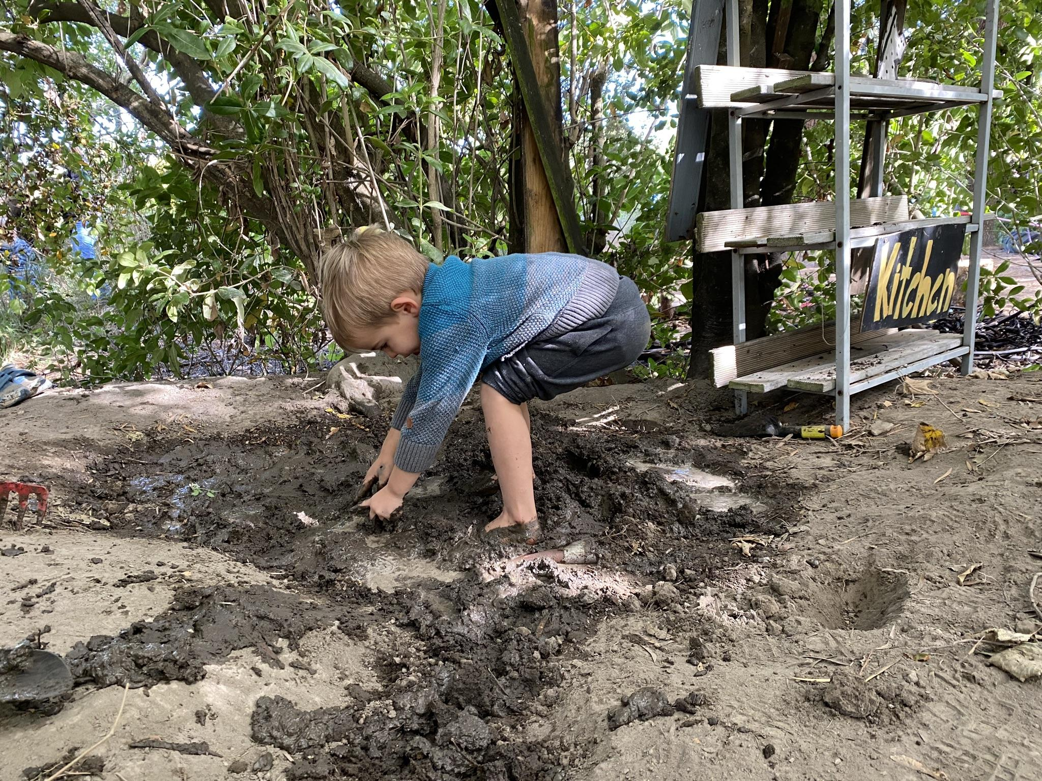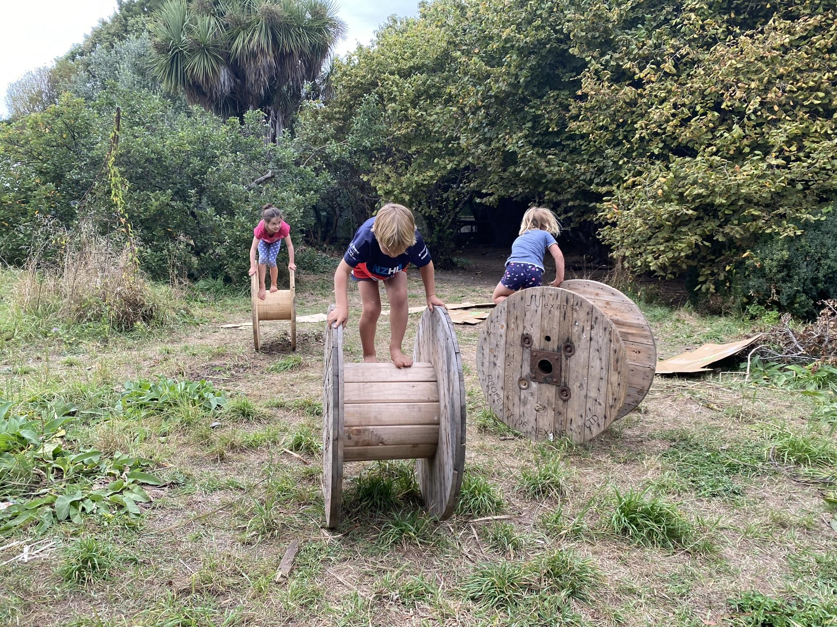

Photographer - Little Kiwis Nature Play (From 2019 Petition Presentation on steps of parliament.
Note: We have a number of MP’s in the Photo - Winston Peters, Ruth Dyson, Chloe Swarbrick, Nicola Willis, Nikki Kaye - and a couple of others that I can’t name at the moment.
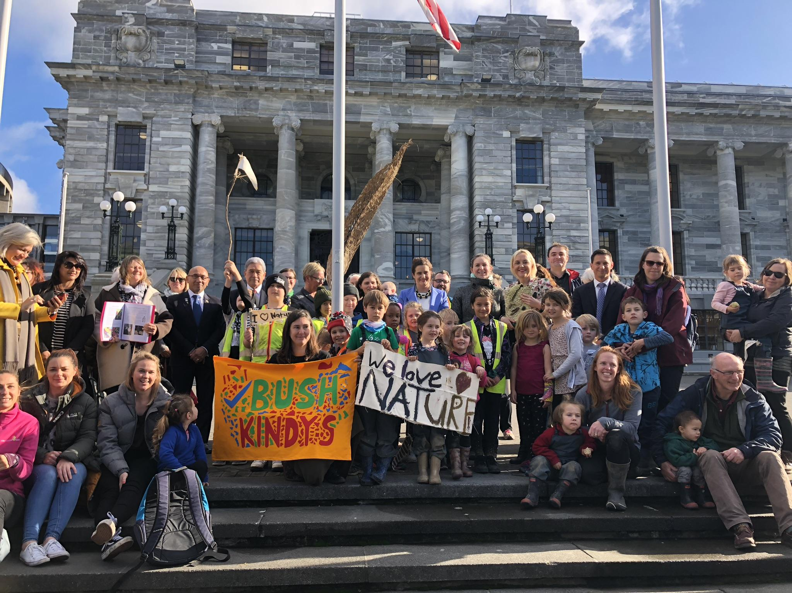

Photographer: Stephanie Defregger
